A11 – Access Control Devices

- Key-Card Access System (RFID Card)
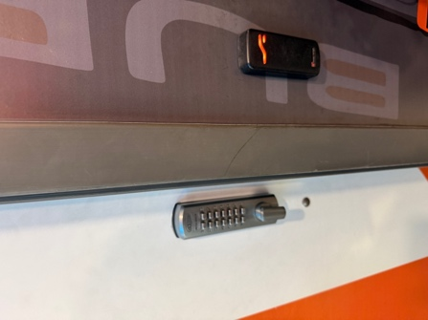

Location: Burk Fuel Station, Landsdale
Explanation:
A key-card system allows access by tapping . The system reads the card information and checks if the user is authorized. If approved, the door unlocks.
Type: RFID Access Control

- Biometric System (Laptop Fingerprint Login)
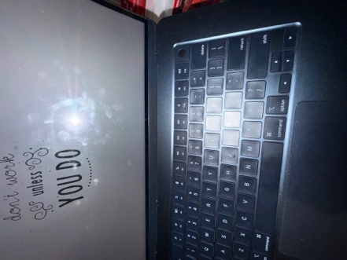

Location: Personal laptop
Explanation:
The laptop fingerprint login system uses biometric authentication. It scans the user’s fingerprint and compares it with stored data. Access is granted only if the fingerprint matches.
Type: Biometric access control
- PIN Pad (Password Entry System)
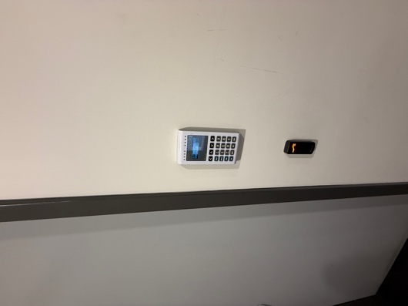

Location: Burk Fuel Station, Landsdale
Explanation:
A PIN pad requires a correct code to unlock a door. Only people who know the code can enter.
Type: Code-Based Access Control

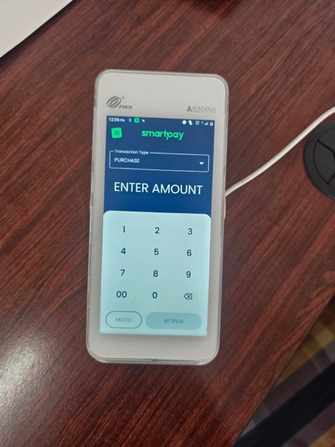
- NFC Payment / Access

Location: S&S Power Coaters, Osborne Park
Explanation:
NFC allows devices like phones or cards to communicate when close. It is used for contactless payments and secure access.
Type: NFC Access Control
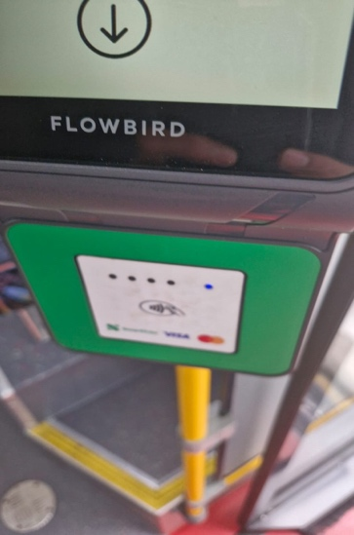
- RFID Tap System

Location: Bus Transport
Explanation:
RFID systems use radio signals to identify a card. When tapped, the system checks access permissions and allows entry.
Type: RFID Access Control

